**Software Architecture Description**

**Project Name:** Automated Equipment Checkout System for GB Manufacturing

**Team Members:** Xavier Norment, Hailey Thomas, Ronda Vaughn, Adam Stone, Anaum Syed

**Author:** Anaum Syed

**Architectural Style:**

Given its connection with project objectives and support for important quality aspects, Objective **Oriented Architecture** (OOA) is the best solution for GB Manufacturing's automated equipment checkout system. OOA stresses system structure around clearly defined objectives, resulting in a modular and adaptable design that adapts easily to changing requirements. By structuring our system around specified goals such as rapid equipment checkout and precise inventory management, we guarantee that each component contributes directly to attaining these goals. This modular approach improves maintainability by allowing updates or alterations to specific components without interrupting the entire system. Furthermore, OOA promotes encapsulation and fault isolation within well-defined modules or objects, which helps to improve reliability. This encapsulation reduces the impact of faults on the system and allows for the introduction of error-handling methods and redundancy measures to improve system resilience. In addition, OOA improves security by encapsulating critical data and functions into objects and allowing regulated access via defined interfaces. Security methods like encryption, authentication, and permission can be incorporated at the object level to provide strong protection against unwanted access or data breaches. OOA also improves functionality by breaking down complicated systems into manageable and reusable components. Clear objectives and contained functionality within objects allow for the efficient deployment of extensive features that fulfill user expectations. The modular architecture of OOA enables easy expansion and modification of functionality to match future additions or changes in business demands. Overall, OOA's emphasis on goals, encapsulation, and modularity makes it the best architectural style for meeting the dependability, security, and functionality requirements of GB Manufacturing's automated equipment checkout system.

**Sequence Diagram:**

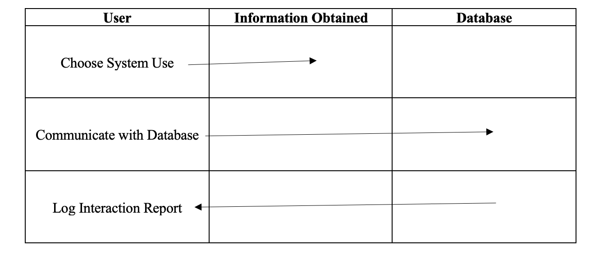

**Machine State Diagram:**

**Dynamic View:**

**Static View:**

